**FITZONE - GYM TRAINER AND PROGRESS**

## TRACKER APPLICATION

**21SBE03 – SOFTWARE DESIGN PATTERN**

## A PROJECT REPORT

***Submitted by***

## KISHORE S 727821TUAD027

***in partial fulfillment for the award of the degree of***

## BACHELOR OF TECHNOLOGY

**IN**

## ARTIFICIAL INTELLIGENCE AND DATA SCIENCE

**NOVEMBER 2023**

## BONAFIDE CERTIFICATE

Certified that this project report **“FITZONE – GYM TRAINER AND PROGRESS TRACKER APPLICATION”** is the bonafide work of **“KISHORE S, DHARMAPRAKASH G and**  **JAYANDRA MUGILAN R A”** who carried out the project work under my supervision.

**SIGNATURE SIGNATURE**

**Dr. R. KARTHIK Dr. C. P. MAHESWARAN**

**SUPERVISOR HEAD OF THE DEPARTMENT**

Associate Professor, Professor,

Department of Computer Science and Department of Artificial Intelligence

Engineering (Cyber Security), and Data Science,

Sri Krishna College of Technology, Sri Krishna College of Technology, Coimbatore-641042. Coimbatore-641042.

Certified that the candidates were examined by us in the Project Viva Voce examination held on at Sri Krishna College of Technology, Kovaipudur, Coimbatore - 641042.

**INTERNAL EXAMINER EXTERNAL EXAMINER**

**ACKNOWLEDGEMENT**

Dedicating this project to the **ALMIGHTY GOD** whose abundant grace and mercies enabled its successful completion.

We extend our deep gratitude to our beloved Principal, **Dr. M. G. Sumithra,** for her kindness and unwavering support throughout the project work.

We are grateful to our beloved Dean Academics affairs and assessment **Dr. R. Rameshkumar,** for his tireless and relentless support.

We extend our heartfelt thanks to our beloved Dean Accreditation and ranking **Dr. P. Manju,** for her advice and ethics inculcated during the entire period of our study.

We would like to express our deep gratitude to **Dr. J. Shanthini,** Head of Computing Science and **Dr. C. P. Maheswaran,** Head of Artificial Intelligence and Data Science, for their exceptional dedication and care towards success of this project.

We would like to extend our heartfelt gratitude to our project guide **Dr. R. Karthik,** Associate Professor, Department of Computer Science and Engineering (Cyber Security) for his valuable guidance and suggestions in all aspects that aided us to ameliorate our skills.

We are thankful to all those who have directly and indirectly extended their help us in completing this project work successfully.

# ABSTRACT

In a world increasingly conscious of health and fitness, the need for a comprehensive and user-friendly gym application has never been more apparent. This report outlines the process of conceptualizing, designing, and developing a state-of-the-art Gym Application, catering to the needs of fitness enthusiasts, gym owners, and trainers. The Gym Application is envisioned as a versatile tool, encompassing features such as workout tracking, personalized training plans, nutrition guidance, and social connectivity, making it a one-stop solution for the fitness community. The Gym Application's development process is documented in stages, from initial ideation and requirement gathering to coding, testing, and deployment. Emphasis is placed on the agile development methodology, ensuring flexibility and adaptability to evolving user needs and industry trends. The Gym Application's ultimate goal is to contribute to a healthier society by making fitness accessible and enjoyable, promoting a lifestyle that embraces well-being. The report provides an in-depth view of this innovative project, shedding light on the intersection of technology, health, and human motivation.

V

# TABLE OF CONTENTS

|  |  |  |
| --- | --- | --- |
| **CHAPTER**  **No.** | **TITLE** | **PAGE No.** |
|  | **ACKNOWLEDGEMENT** | **III** |
|  | **ABSTRACT** | **IV** |
|  | **LIST OF FIGURES** | **VII** |
|  | **LIST OF ABBREVATIONS** | **VIII** |
| 1 | **INTRODUCTION** | 1 |
|  | 1.1 PROBLEM STATEMENT | 2 |
|  | 1.2 OVERVIEW | 2 |
|  | 1.3 OBJECTIVE | 2 |
| 2 | **LITERATURE SURVEY** | 3 |
| 3 | **SYSTEM SPECIFICATIONS** | 5 |
|  | 3.1 BACKEND DEVELOPMENT | 5 |
|  | 3.1.1 REST API - SPRINGBOOT | 6 |
|  | 3.1.2 MICROSERVICES | 7 |
|  | 3.1.3 EUREKA | 7 |
|  | 3.1.4 JWT | 7 |
|  | 3.2 DATABASE MANAGEMENT | 8 |
|  | 3.2.1 MYSQL | 9 |
| 4 | **SOFTWARE REQUIREMENTS** | 10 |

vi

|  |  |  |
| --- | --- | --- |
| 5 | **BACKEND IMPLEMENTATION** | 10 |
|  | 5.1 MAIN CONTROLLER | 11 |
|  | 5.1.1 AUTHENTICATION CONTROLLER | 11 |
|  | 5.1.2 GYMUSER CONTROLLER | 12 |
|  | 5.1.3 TRAINER CONTROLLER | 13 |
|  | 5.1.4 MICROSERVICE CONTROLLER | 13 |
|  | 5.2 MAIN REPOSITORY | 14 |
|  | 5.2.1 USER REPOSITORY | 14 |
|  | 5.2.2 FEEDBACK REPOSITORY | 15 |
|  | 5.2.3 GYMUSER REPOSITORY | 15 |
|  | 5.2.4 TRAINER REPOSITORY | 15 |
|  | 5.3 SECURITY | 16 |
|  | 5.3.1 JWT TOKEN | 16 |
|  | 5.3.2 SECURITY CONFIGURATIONS | 17 |
|  | 5.4 API GATEWAY | 18 |
|  | 5.5 EUREKA | 18 |
| 6 | **CONCLUSION** | 19 |
|  | **REFERENCES** | 20 |

# LIST OF FIGURES

|  |  |  |
| --- | --- | --- |
| **Figure No.** | **TITLE** | **Page No.** |
| 5.1.1 | Authentication Controller | 11 |
| 5.1.2 | Gymuser Controller | 12 |
| 5.1.3 | Trainer Controller | 13 |
| 5.2.1 | User Repository | 14 |
| 5.3.1 | Token Generation | 16 |
| 5.3.2 | Security Configuration | 17 |
| 5.4 | API Gateway | 18 |
| 5.5 | Eureka Server | 18 |

**LIST OF ABBREVIATIONS**

|  |  |
| --- | --- |
| **ABBREVIATIVE** | **ABBREVIATION** |
| JSON | JAVASCRIPT OBJECT NOTATION |
| JWT | JAVASCRIPT WEB TOKEN |
| HTTP | HYPER TEXT TRANSFER PROTOCOL |
| API | APPLICATION PROGRAMMING INTERFACE |
| SQL | STRUCTURED QUERY LANGUAGE |

# CHAPTER 1

# INTRODUCTION

The Gym Application is a complete fitness ecosystem, designed to adapt to our unique needs and goals. Whether you're an early bird hitting the gym, a busy professional seeking quick home workouts, or a weekend warrior exploring new routines, this app accommodates our lifestyle. Our seamless wearable integration allows you to sync our favorite fitness trackers, ensuring that you get the most accurate and comprehensive data on our physical activity and health stats. Plan our workouts in advance, set reminders, and establish a consistent routine with the Workout Scheduler feature. It's the key to maintaining our commitment and achieving long-term success. Moreover, our achievement badge system rewards our dedication and perseverance, giving you a sense of accomplishment with each milestone you reach. The Ultimate Gym Application isn't just an app; it's our personal fitness coach, our nutritionist, our community, and our source of inspiration. It's time to embark on our fitness journey with confidence, knowing that success is within reach. Let's make our health and fitness dreams a reality.

# 1.1 PROBLEM STATEMENT

To build a Gym Trainer and Progress Tracker Application using React (Frontend), Spring Boot Microservices (Backend), and MySQL (database).

# 1.2 OVERVIEW

The Gym Application is our all-in-one solution for achieving our fitness goals and embracing a healthier lifestyle. With its personalized workouts, exercise instructions, and a vast array of nutrition guidance, it ensures you have the tools and knowledge to succeed in our fitness journey. Real-time progress tracking keeps you accountable and motivated, allowing you to see our achievements unfold before our eyes. It will make our health and wellness aspirations a reality.

# 1.3 OBJECTIVE

The primary objective of the Gym Application is to empower individuals to achieve their fitness and wellness goals effectively and efficiently by providing a comprehensive, user-friendly, and personalized fitness platform. The application aims to offer tailored workout routines, expert guidance on exercise and nutrition, real-time progress tracking, a supportive community. The ultimate goal is to inspire and assist users, regardless of their fitness level or background, in their pursuit of a healthier and more active lifestyle.

# CHAPTER 2 LITERATURE SURVEY

In Gym applications have become a cornerstone of the digital fitness revolution, offering users an array of tools and resources that cater to their individual health and wellness needs. They empower individuals by granting them instant access to personalized workout routines, nutritional guidance, and the ability to track their fitness progress.

The reviewed literature consistently highlights the numerous advantages of these applications, including their convenience, flexibility, and potential to foster motivation. Users can access expert advice, engage with fitness communities, and experience a sense of achievement through workout tracking and achievement badges. However, challenges such as user engagement and adherence pose noteworthy hurdles. As the fitness app landscape continues to evolve, it becomes increasingly evident that in-depth research is essential to refine and enhance the user experience while addressing the identified gaps.

In this context, gym applications have the potential not only to revolutionize individual fitness journeys but also to transform the broader health and wellness landscape. The implications of these findings underscore the importance of user engagement and adherence strategies for both application developers and users alike, as we collectively pursue healthier, more active lifestyles.

The literature survey on gym applications underscores their pivotal role in modern fitness and wellness. Gym applications offer a convenient and accessible means for individuals to engage in tailored workouts, access nutritional guidance, and track their fitness progress.

Research suggests that these apps hold substantial potential for motivating users and helping them reach their fitness goals. However, they also face challenges related to user engagement and long-term adherence. This survey identifies a critical need for further research in understanding and enhancing user engagement strategies and in assessing the efficacy of gym applications for specific fitness objectives and diverse user populations. In conclusion, gym applications are poised to reshape the fitness landscape, but their continued success hinges on addressing the highlighted gaps and optimizing user experiences. This literature survey sheds light on the path forward, emphasizing the importance of effective engagement and adherence strategies for developers and users alike.

A gym application encompasses a comprehensive review of existing research, studies, and literature related to the development and usage of fitness and workout applications. Numerous studies have examined the benefits of mobile applications in promoting physical activity and healthy lifestyle choices. Research has shown that such applications can significantly enhance user engagement, motivation, and adherence to fitness routines. Furthermore, studies have explored the impact of wearable fitness technology integration with gym applications, shedding light on the potential for real-time tracking and data analysis to improve exercise outcomes. By examining this body of literature, one can gain valuable insights into the latest trends and best practices in the development of gym applications, ultimately contributing to the creation of more effective and user-friendly fitness tools.

Gym applications have the potential to significantly impact the fitness and wellness landscape by providing accessible and personalized fitness solutions. Understanding the factors that influence user engagement and adherence is essential for both developers and users to fully realize the benefits of these applications.

# CHAPTER 3 SYSTEM SPECIFICATIONS

**3.1 BACK-END DEVELOPMENT**

Back-End Developmentrefers to the server-side development. It focuses on databases, scripting, and website architecture. It contains behind-the-scenes activities that occur when performing any action on a website. It can be an account login or making to fit for a healthy life. Code written by back-end developers helps browsers to communicate with database information.

* + 1. **REST API – SPRING BOOT**

Representational State Transfer (REST) is an architectural style that defines a set of constraints to be used for creating web services. REST APIis a way of accessing web services in a simple and flexible way without having any processing. REST technology is generally preferred to the more robust Simple Object Access Protocol (SOAP) technology because REST uses less bandwidth, simple and flexible making it more suitable for internet usage. It’s used to fetch or give some information from a web service. All communication done via REST API uses only HTTP request.

**Working:** A request is sent from client to server in the form of a web URL as HTTP GET or POST or PUT or DELETE request. After that, a response comes back from the server in the form of a resource which can be anything like HTML, XML, Image, or JSON. But now JSON is the most popular format being used in Web Services.

Spring Boot provides a good platform for Java developers to develop a stand-alone and production-grade spring application that you can just run.

You can get started with minimum configurations without the need for an entire Spring configuration setup. Spring Boot automatically configures our application based on the dependencies you have added to the project by using **@EnableAutoConfiguration** annotation. For example, if MySQL database is on our classpath, but you have not configured any database connection, then Spring Boot auto-configures an in-memory database.

The entry point of the spring boot application is the class contains **@SpringBootApplication** annotation and the main method. Spring Boot automatically scans all the components included in the project by using **@ComponentScan** annotation.

### MICROSERVICES

Microservices are a software development approach that structures an application as a collection of loosely coupled services. Each service is self-contained and performs a specific task. Microservices communicate with each other through well-defined APIs.

**Embedded servers:** Spring Boot can embed a web server in the application, so there is no need to deploy the application to a separate server. This makes it easy to develop and deploy microservices.

**Autoconfiguration:** Spring Boot can automatically configure many common Spring features, such as database connections and web servers. This reduces the boilerplate code that developers need to write and makes it easier to get started with microservices.

**Starters:** Spring Boot starters are groups of dependencies that are pre-configured for specific tasks, such as developing microservices with REST APIs or messaging queues. Starters make it easy to get started with microservices and avoid common configuration mistakes.

### EUREKA

Eureka is one of the great libraries of Netflix OSS particularly focused

on service discovery and spring has a fluent integration with it. In this story, they will share a very basic example containing 4 modules:

**Eureka-server:** The service registry

**Eureka-dto**: The DTO container module

**Eureka-client**: A microservice containing a sample REST endpoint.

**Eureka-feign-client**: A sample application consuming the REST endpoint provided by the eureka-client.

Note that all these modules share the same Maven parent project in which project lombok is added under the dependencies section. Therefore, you’ll not see it in the dependencies section of any module. By default, Eureka server is also a Eureka client and it can register itself to other Eureka server so that they can work as peers. This way our service registry becomes more resilient to failures. But, if you want to switch off the client behavior of our service registry and want a single registry instance, then you should disable register-with-eureka and fetch-registry configurations

### JWT

JWT, or JSON Web Token, is an open standard (RFC 7519) that define

a compact and self-contained way for securely transmitting information between parties as a JSON object. This information can be verified and trusted because it is digitally signed.

A JWT consists of three parts:

**Header**: The header contains information about the token, such as the type of token and the signing algorithm used.

**Payload**: It contains the statements about the user or the application.

**Signature**: The signature is used to verify the integrity of the token.

JWTs can be used for a variety of purposes, such as:

**Authentication**: JWTs can be used to authenticate users. When a user successfully logs in, the server can generate a JWT and send it to the user. The user can then store the JWT in their browser or in local storage. When the user needs to access a protected resource, they can send the JWT to the server. The server can then verify the JWT and authenticate the user.

**Authorization**: JWTs can be used to authorize users to perform specific actions. For example, a JWT can contain a claim that gives the user permission to access a certain resource. When the user needs to access the resource, they can send the JWT to the server. The server can then verify the JWT and authorize the user to access the resource.

**Information exchange**: JWTs can be used to securely exchange information between parties. For example, a JWT can contain information about a user, such as their name and email address. When a user needs to share this information with another party, they can send the JWT to the other party. The other party can then verify the JWT and trust the information in the payload.

# 3.2 DATA BASE MANAGEMENT

Database management [2] refers to the actions a business takes to manipulate and control data to meet necessary conditions throughout the entire [data](https://www.informatica.com/in/services-and-training/glossary-of-terms/information-lifecycle-management-definition.html) [lifecycle.](https://www.informatica.com/in/services-and-training/glossary-of-terms/information-lifecycle-management-definition.html) Database management has become more important as the volume of business data has grown. Rapid data growth creates a wide variety of negative conditions, including poor application performance and compliance risk, to name a few. Database management comprises a number of proactive techniques to prevent the deleterious effects of data growth. This includes performance monitoring and tuning, storage and capacity planning, backup and recovery, data archiving, data partitioning, replication, [masking,](https://www.informatica.com/in/services-and-training/glossary-of-terms/data-masking-definition.html) and retirement.

**3.2.1 MYSQL**

MYSQLis an [open-source](https://en.wikipedia.org/wiki/Open-source_software) [relational database management](https://en.wikipedia.org/wiki/Relational_database_management_system) [system](https://en.wikipedia.org/wiki/Relational_database_management_system) (RDBMS). Its name is a combination of "My", the name of co - founder Wideness’s daughter “My” and "SQL", the acronym for [Structured Query](https://en.wikipedia.org/wiki/Structured_Query_Language) [Language.](https://en.wikipedia.org/wiki/Structured_Query_Language) A [relational database](https://en.wikipedia.org/wiki/Relational_database) organizes data into one or more data tables in which data may be related to each other; these relations help structure the data. SQL is a language programmers use to create, modify and extract data from the relational database, as well as control user access to the database. In addition to relational databases and SQL, an RDBMS like MySQL works with an [operating system](https://en.wikipedia.org/wiki/Operating_system) to implement a relational database in a computer's storage system, manages users, allows for network access and facilitates testing database integrity and creation of backups.

# CHAPTER 4 SOFTWARE REQUIREMENTS

**Operating System :** Runs in any operating system

(Not Specific)

**Front End :** React JS

**Back End :** REST API - SPRING BOOT

### Data Base Management : MYSQL

I**DE Used :** Visual Studios Code (VS-Code) , Spring Tool Suite (STS) , Eclipse.

**RAM :** 2 to 3 times the size of the database.

**Storage :** Minimum of 50 GB Storage

**Processor :** Any Quad Core Processors (3.3Ghz)

**Connectivity :** Internet speed of min.2Mbps

**CHAPTER 5**

**BACKEND IMPLEMENTATION**

# 5.1 MAIN CONTROLLER

The Main Controller of our project consists of 4 files namely Gymuser Controller, Authentication Controller, Trainer Controller and Microservice Controller.

### AUTHENTICATION CONTROLLER

User Controller consists of functions which carry on the process of login / signup, signup as a user and to get all the details from the database.

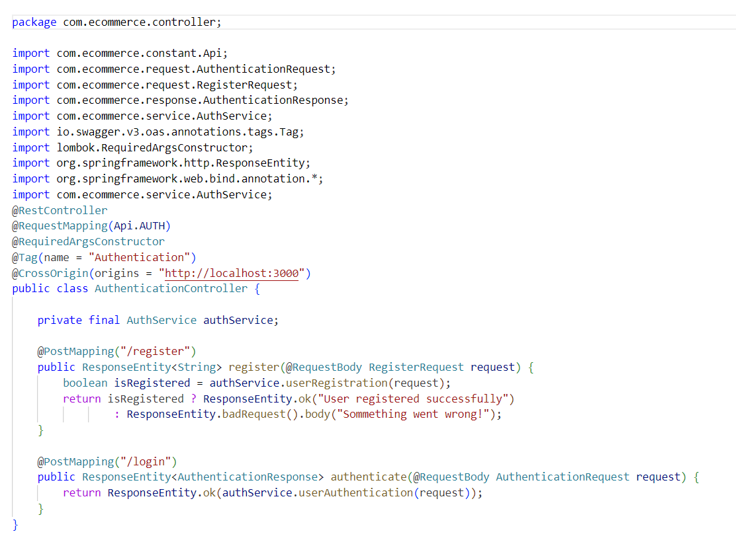

### Fig 5.1.1 – Authentication Controller

* + 1. **GYMUSER CONTROLLER**

The Gymuser Controller consists of functions where a specific user can to add the additional information for fitness. Admin can able to delete the user information.

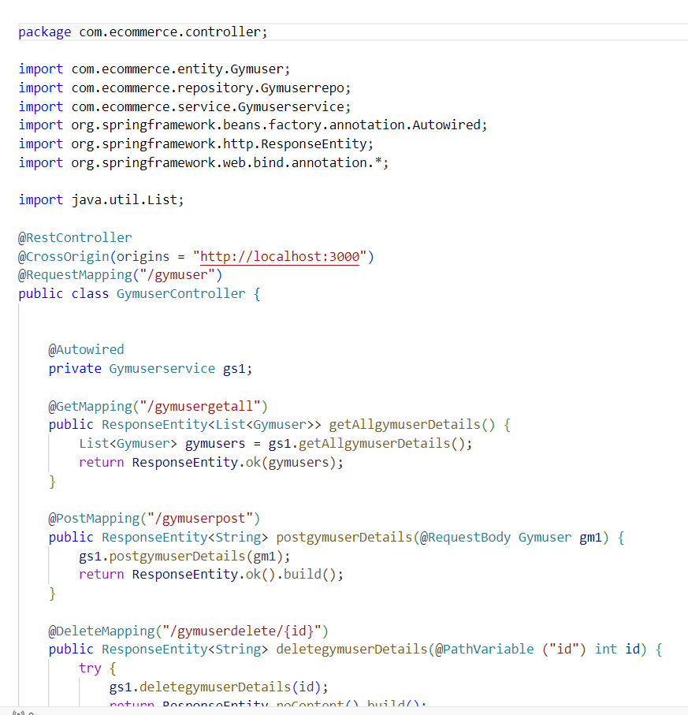

### Fig 5.1.2 – Gymuser Controller

* + 1. **TRAINER CONTROLLER**

Trainer Controller consists of functions that can able to check the user progress about their fitness.

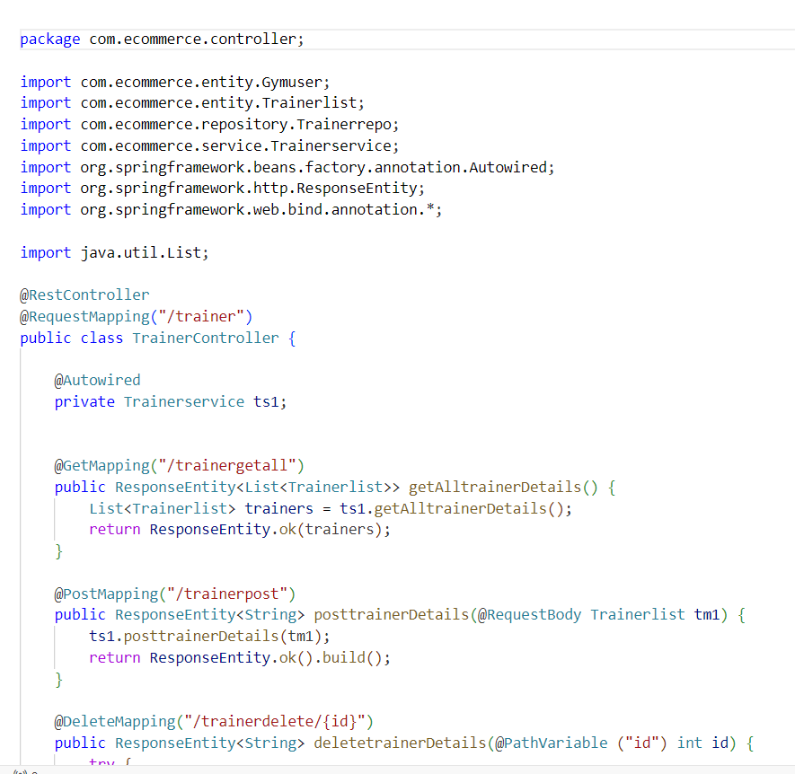

### Fig 5.1.3 – Trainer Controller

* + 1. **MICROSERVICE CONTROLLER**

Microservice Controller is used to connect with other services using RestTemplate class. The Microservice includes feedback for the application and also for a trainer. This controller will invoke another function which will be in the controller of support server which is running in another port.

### 

### 5.2 MAIN REPOSITORY

The Main Repository consists of User repository, Feedback repository, Gymuser repository and Trainer repository. These files has native SQL queries which performs the operations of controllers.

### 5.2.1 USER REPOSITORY

A Spring Data JPA repository called User Repository for managing user data. It extends the JpaRepository interface, indicating that it handles the User entity with a primary key of type Long. This repository offers methods to find users by their email, by their unique identifier, and to delete users by their identifier. It simplifies common database operations and eliminates the need for writing SQL queries when working with user data in a Spring Boot application.

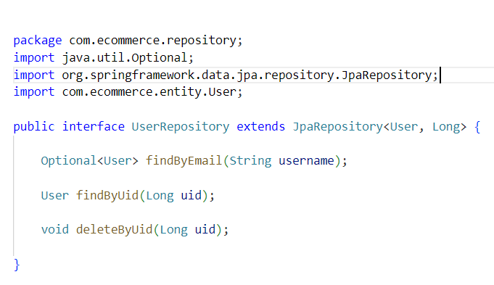

### 

### Fig 5.2.1 – User Repository

### 5.2.2 FEEDBACK REPOSITORY

A Spring Data JPA repository simplifies database access in Spring Boot. The repository defines a Spring Data JPA repository called Feedback Repository, responsible for managing feedback from the users. It extends the JpaRepository interface and specifies that it works with the feedback entity, which uses an Integer as the primary key type.

### 5.2.3 GYMUSER REPOSITORY

A Spring Data JPA repository simplifies database access in Spring Boot. This repository provides common Create, Read, Update, Delete methods which automates the database operations. User repository manages the user details with an Integer primary key, making data access easy and efficient in our application.

### 5.2.4 TRAINER REPOSITORY

A Spring Data JPA repository simplifies database access in Spring Boot. The repository defines a Spring Data JPA repository called Trainer Repository, responsible for managing workouts related to user needed. It extends the JpaRepository interface and specifies that it works with the Trainer entity, which uses an Integer as the primary key type.

# 

# 5.3 SECURITY

The JWT(Json Web Token) is an encrypted signature generated for a specific user logged in. All the further operations are carried on with the help of this token. If someone get this token they can’t misuse it as it is encrypted strongly and the cannot get the username and password.

### 5.3.1 JWT TOKEN

The JWT(Json Web Token) is an encrypted signature generated for a specific user logged in. All the further operations are carried on with the help of this token. If someone get this token they can’t misuse it as it is encrypted strongly and the cannot get the username and password.

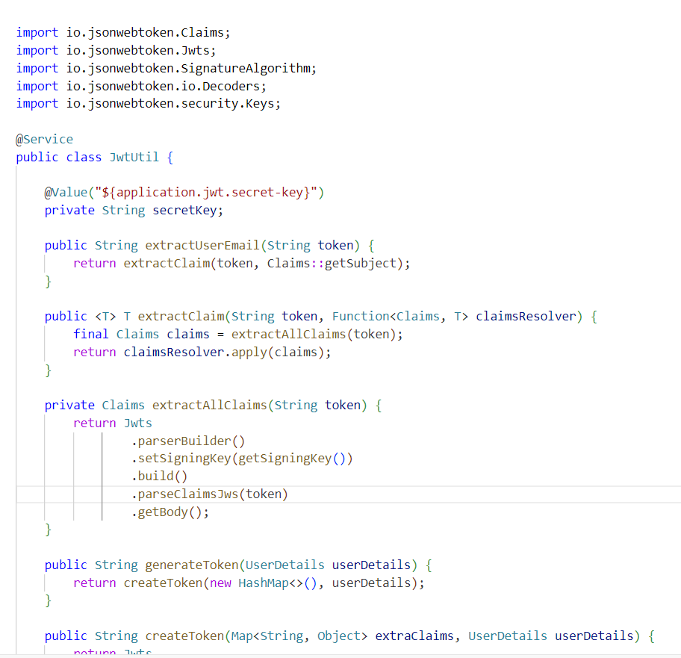

### Fig 5.3.1 – Token Generation

**5.3.2 SECURITY CONFIGURATION**

Security Configuration file is used to specify which HTTP requests need to be allowed and which one should be denied. With the help of JWT filter file it will extract the value from the token and authenticate the routes that are specified.

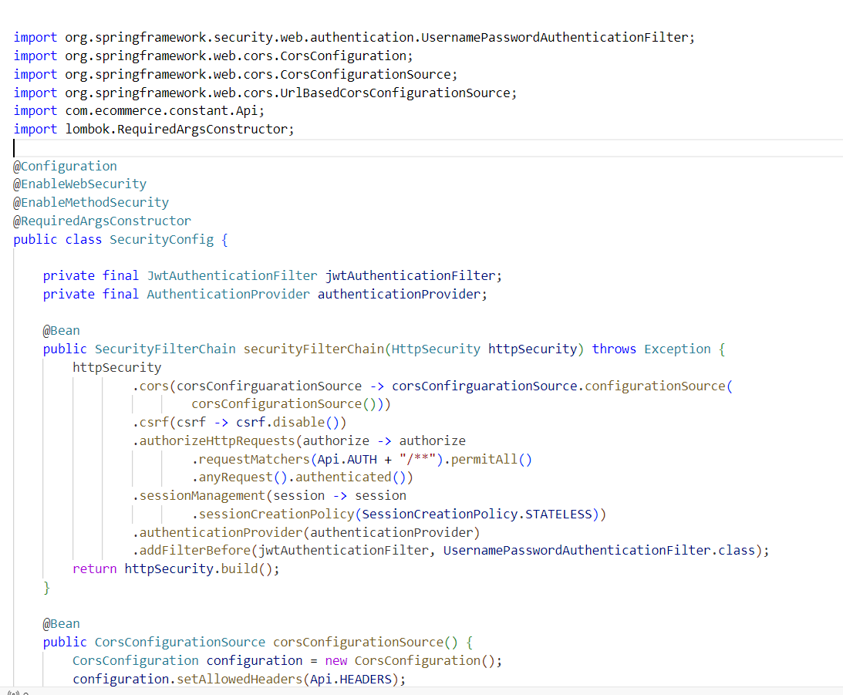

**Fig 5.3.2 – Security Configuration**

# 5.4 API GATEWAY

An API gateway is a component of the app-delivery infrastructure that sits between clients and services and provides centralized handling of API communication between them. It also delivers security, policy enforcement, and monitoring and visibility across on-premises, multi-cloud, and hybrid environments. It is where the request for a website is comes in and response for that particular request is sent out.

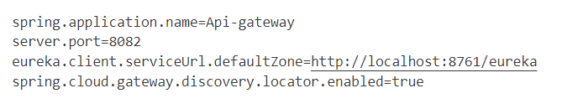

**Fig 5.4 – API Gateway**

# 5.5 EUREKA

The Eureka Server acts as a centralized registry, where microservices can register themselves and advertise their availability. It maintains a dynamic directory of available services, allowing other services to locate and communicate with each other. It is used to know the status of our website whether it is in Up or Down.

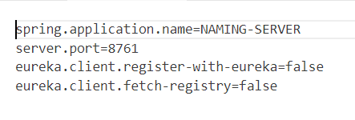

**Fig 5.5 – Eureka Server**

# CHAPTER 6 CONCLUSION

In conclusion, building a REST API project involves careful consideration of various components and principles to ensure a well-designed and functional API. Here are some key points to remember. Follow a consistent and intuitive URL structure, utilize appropriate HTTP methods, and ensure meaningful and consistent response formats. Implement secure authentication mechanisms, such as token- based authentication or OAuth, to protect our API endpoints from unauthorized access. Apply proper authorization rules to control the actions that different users or roles can perform. Handle errors gracefully by providing meaningful error messages and appropriate HTTP status codes in response to client requests. Include tests for various scenarios, such as positive and negative cases, edge cases, and performance testing, to ensure robustness. Document our API endpoints, including their purpose, input/output formats, and any required headers or parameters. Consider horizontal scaling options, such as load balancing and clustering, to handle increased traffic or future growth. Implement logging to record important events and errors for debugging purposes. Monitor the performance and usage of our API using tools like monitoring dashboards, log analysis, or API analytics platforms. Consider implementing versioning strategies for our API to allow for backward compatibility and smooth upgrades. This ensures that clients can continue using older versions of our API while new versions are introduced. Implement security best practices, such as input validation, secure communication over HTTPS, and protection against common vulnerabilities like SQL injection or cross-site scripting (XSS).

# 

# REFERENCES

1. A. Goldberg and D. Robson, Smalltalk-80 The Language and Its Implementation, Addison-Wesley, 1983.
2. B. C. Schwab, K. Hemmaplardh, S. A. Sackett, C. M. Kitto, D. J. Inglis and C.

D. Meier, "A Developed Database Management System For Operation and Planning Applications", IEEE Transactions on Power Apparatus and Systems, vol. PAS-104, no. 7, pp. 1637-1643, July 2002.

1. Chris Richardson, "Microservices Patterns: With examples in Java," Manning Publications, 2018.
2. Fang Kong, Research on the Management of Data System and Honor Archives in China, Nanjing University, 2017.
3. H. Daniels and N. Mayur, "More Than Mainframes", IEEE Spectrum, pp. 54- 61, August 2007.
4. Michael Stonebraker and Paul Brown, "Object-Relational DBMSs: The Next Great Wave", Morgan Kaufmann, 1999.
5. V. N. Anh and A. Moffat. "Inverted Index Compression Using Word-Aligned Binary Codes". Information Retrieval, 8(1):151-166, 2016.
6. W. G. Aref and I. F. Ilyas. "SP-GiST: An Extensible Database Index for Supporting Space Partitioning Trees". J. Intell. Inf. Syst., 17(2-3):215-240, 2011.